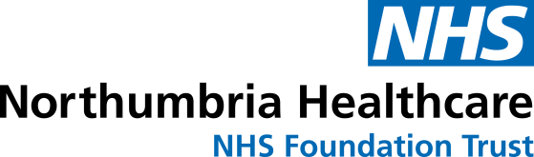

**RAISING MONEY FOR**

**BRIGHT NORTHUMBRIA**

**HEALTHCARE CHARITY**

**NAME:**

**DATE:**

Bright Northumbria Healthcare Charity is the official charity of Northumbria Healthcare NHS Foundation Trust. I am running to raise fund for this cause. Any donations are gratefully received.

We who have given our names and addresses below, and who have ticked the box headed ‘Gift Aid’ want the charity to reclaim tax on the donation detailed below, given on the date shown. We understand that each of us must pay an amount of income tax on capital gains equal to the tax reclaimed by the charities on the donation.

|  |  |  |  |  |  |
| --- | --- | --- | --- | --- | --- |
| **NAME** | **HOME ADDRESS** | **POST CODE** | **PLEDGED £** | **DATE PAID** | **GIFT AID** |
|  |  |  |  |  | □ |
|  |  |  |  |  | □ |
|  |  |  |  |  | □ |
|  |  |  |  |  | □ |
|  |  |  |  |  | □ |
|  |  |  |  |  | □ |
|  |  |  |  |  | □ |
|  |  |  |  |  | □ |
|  |  |  |  |  | □ |
|  |  |  |  |  | □ |

|  |  |  |  |  |  |
| --- | --- | --- | --- | --- | --- |
| **NAME** | **HOME ADDRESS** | **POST CODE** | **PLEDGED £** | **DATE PAID** | **GIFT AID** |
|  |  |  |  |  | □ |
|  |  |  |  |  | □ |
|  |  |  |  |  | □ |
|  |  |  |  |  | □ |
|  |  |  |  |  | □ |
|  |  |  |  |  | □ |
|  |  |  |  |  | □ |
|  |  |  |  |  | □ |
|  |  |  |  |  | □ |
|  |  |  |  |  | □ |
|  |  |  |  |  | □ |
|  |  |  |  |  | □ |
|  |  |  |  |  | □ |
|  |  |  |  |  | □ |
|  |  |  |  |  | □ |

**THANK YOU FOR YOUR SUPPORT**

Please make cheques payable to ‘**Northumbria Healthcare Charity’** and return a copy of your sponsorship form so that we can claim gift aid. Please post to: Bright Charity, Northumbria Healthcare NHS Foundation Trust, 7/8 Silver Fox Way, Cobalt Business Park, Newcastle upon Tyne, NE27 0QJ.